Shared goals of care

  - A guide to preparing and implementing
your shared goals of care approach

April 2021

About this guide
This guide is intended to help project leads and teams prepare for and implement improvements to their shared goals of care approaches. It sets out why this is important, components to be implemented, available support, and recommended activities during the preparation, implementation and sustain periods.

Contents
Introduction 3
A shared goals of care approach 4
Shared goals of care principles 4
Goals of care options 5
The case for change 6
Factors for successful implementation 8
Tools, guidance, training resources and support for project teams 9
Prepare for implementation 10
1. Plan your project 10
2. Prepare what you will do and how you will do it 12
3. Do small-scale tests of the shared goals of care approach 15
4. Prepare for spread and implementation 16
Implement 18
Appendix A: Quality improvement approach 19
Appendix B: The Serious Illness Conversation Guide 21
Appendix C: Shared goals of care discussion infographic 22
References 23

Introduction
Patients deteriorate in hospital for many reasons. Failures to recognise, escalate and respond appropriately can cause preventable harm. To address this, hospitals have been improving their systems for managing the care of patients who deteriorate.
Recognition and response systems should include:
- a nationally standardised vital signs chart with New Zealand early warning score
(or electronic equivalent)
- a localised escalation pathway
- effective clinical governance and leadership
- appropriate clinical and non-technical education and training
- ongoing measurement for improvement
- Kōrero mai (patient and whānau escalation of care) processes
- approaches to shared goals of care discussions and decision-making.
This guide focuses on the shared goals of care approach within the recognition and response system.
We are asking hospitals to align their current approaches with the shared goals of care principles.
We recognise that current approaches vary. Some district health boards (DHBs) have already implemented a shared goals of care approach within one or all their hospitals, some are starting to adapt their existing approach, and others have not yet started.
This will mean that different hospitals will need variable periods of time to prepare and implement system improvements in line with the shared goals of care principles. There are five stages to preparation and implementation (Figure 1).
Figure 1: Preparation and implementation stages

Engaging with and involving patients, whānau, and clinical, operational and executive staff is critical to establishing successful and sustainable approaches to shared goals of care.

A shared goals of care approach
Shared goals of care are when the patient, their family and whānau, and clinicians explore the patient’s values along with the care and treatment options available and agree the goal of care for the current admission. This decision describes what will be offered if the patient deteriorates. This is a move away from the binary decision-making of ‘for/not for resuscitation’.
Shared goals of care discussions take place before episodes of acute deterioration so everyone can engage fully without the pressures of an evolving clinical crisis. Hospitals should aim to have these discussions documented for all adult patients, ideally within 24 hours of admission, by appropriately trained staff. These are then reviewed and documented if there are changes in the patient’s condition. If patients have advance care plans and/or advance directives, these need to support the discussion.
A systems-level approach is needed to ensure that these discussions are encouraged and resourced and that patients, whānau and clinicians are supported. The shared goals of care principles support hospitals’ project teams to establish this approach.

Shared goals of care principles
- Shared goals of care are when the patient, their family and whānau, and clinicians explore the patient’s values along with the care and treatment options available and agree the goal of care for the current admission if the patient deteriorates.
- Health service providers ensure that governance systems and organisational culture and structures encourage shared goals of care discussions through resourcing and by supporting patients, whānau and clinicians to have these discussions.
- Cultural safety is an essential component of shared goals of care discussions.
- Patients, whānau and clinicians are supported before, during and after shared goals of care discussions.
- Patients have those they want to have with them, including those who have decision-making responsibilities.
- Shared goals of care discussions take place in appropriate environments to maintain patients’ privacy and dignity.
- Shared goals of care discussions are facilitated by the appropriate clinician(s) and may include other members of multi-disciplinary teams involved in patients’ care.
- Shared goals of care discussions happen as early in the admission as possible and with the agreement of the patient. The patient, whānau or clinician can begin the discussion.
- Shared goals of care discussions result in a shared understanding through engaging with patients and whānau, sharing clinicians’ understanding and exploring patients’ values and what is important to them.
- Shared goals of care discussions and decisions are documented in a clearly identifiable and accessible clinical form, with information available to all clinicians caring for patients.
See the Shared goals of care principles for health service providers document on the Health Quality & Safety Commission’s (the Commission) website for more detail about these principles.

Goals of care options
There are four goals of care options to choose from (A&B: curative and restorative, C: quality of life, D: comfort while dying). There are agreed medical interventions for each option (Table 1).
Table 1: Shared goals of care options and interventions
 | Treatment aims to | Cardiopulmonary resuscitation | Rapid response calls | Referral for ICU-level care | Other options
A:  Curative and restorative | Prolong life | Attempt as this is clinically recommended and in line with the person’s known wishes | Appropriate | Appropriate | All appropriate life-sustaining treatments
B:  Curative and restorative | Prolong life and enhance its quality | Do not attempt as this is likely to cause more harm than benefit or is not desired by the person | Appropriate | Decide if appropriate | Appropriate treatments
C:  Improving quality of life | Control symptoms, enhance wellbeing, and should be easily tolerated | Do not attempt as this is likely to cause more harm than benefit | Decide if appropriate | Unlikely to be appropriate | Appropriate treatments
D:  Comfort whilst dying | Alleviate suffering in the last hours or days of life and allow a natural death | Do not attempt as this is likely to cause more harm than benefit | Not appropriate | Not appropriate | End-of-life guidelines like Te Ara Whakapiri and other appropriate treatments

See Appendix C for an infographic on what goes into having a shared goals of care discussion.

The case for change
Acute deterioration can happen at any point during a patient’s hospital admission. If acute deterioration is recognised early and responded to appropriately, patient outcomes can be improved. Internationally, more than 20 percent of rapid response team reviews are associated with end-of-life decision-making. This suggests that end-of-life decision-making is often delayed until a crisis occurs.
There are significant opportunities to work with patients to identify, discuss and document their care preferences and goals earlier in an episode of hospital care. Earlier discussion and documentation of patients’ goals of care will enable the response to be aligned with their wishes if they deteriorate. Ideally, such conversations occur prior to episodes of acute deterioration so patients, whānau and clinicians can participate fully in developing shared goals of care without the pressures of an evolving clinical crisis.
Early conversations about what matters most to a patient and how we can work together to incorporate the patients’ values and goals into the care and treatment offered has been associated with better outcomes for patients and their families and whānau.,,
At times clinicians avoid discussing prognosis, what really matters to the patient, and end-of-life issues with patients because they feel uncomfortable having these discussions. Their discomfort comes from:
- a perceived lack of training
- stress
- not enough time to attend to what might come up for the patient
- a fear of upsetting the patient
- a feeling of inadequacy or hopelessness regarding availability of further curative treatment.
Avoiding these conversations or only initiating them late can lead to:
- anxiety and poorer patient quality of life
- patient and whānau distress
- prolonging the dying process
- unwanted and unwarranted treatments and their complications
- patient mistrust of the health system
- clinician distress
- low value care in which seriously ill patients do not receive the kind of care they desire.
It is in the patient’s best interests to offer prognosis information rather than withhold it to protect the patient from losing hope or being upset. Patients and whānau want open and honest information and a balance between realistic information and appropriate hope. Evidence suggests that patients can engage in such discussions with minimal stress and maintain a sense of hope even when the prognosis is poor.^{3,4,5} Recent feedback from clinicians and consumers reinforced this, as outlined in the following infographics.

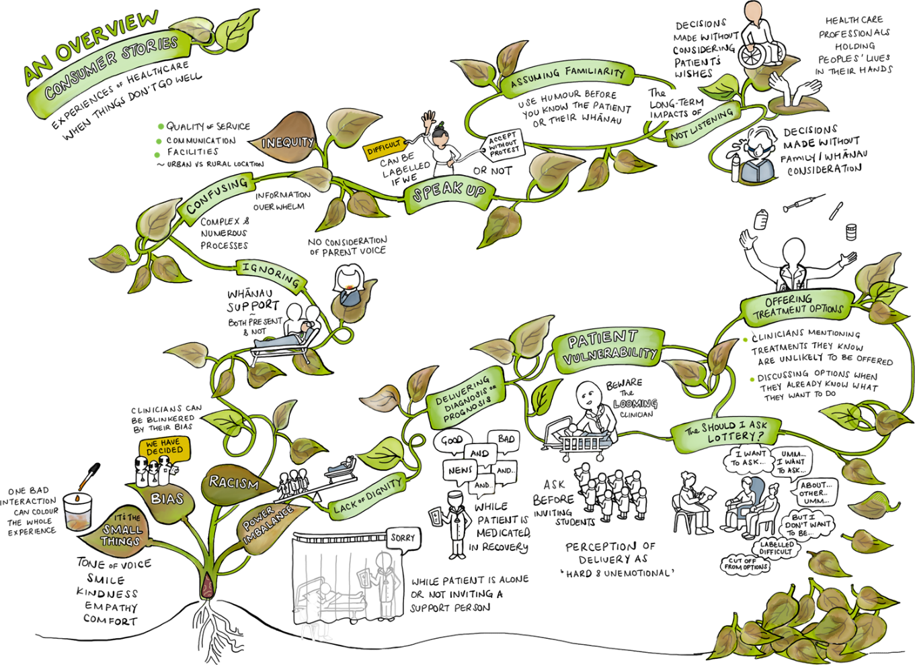

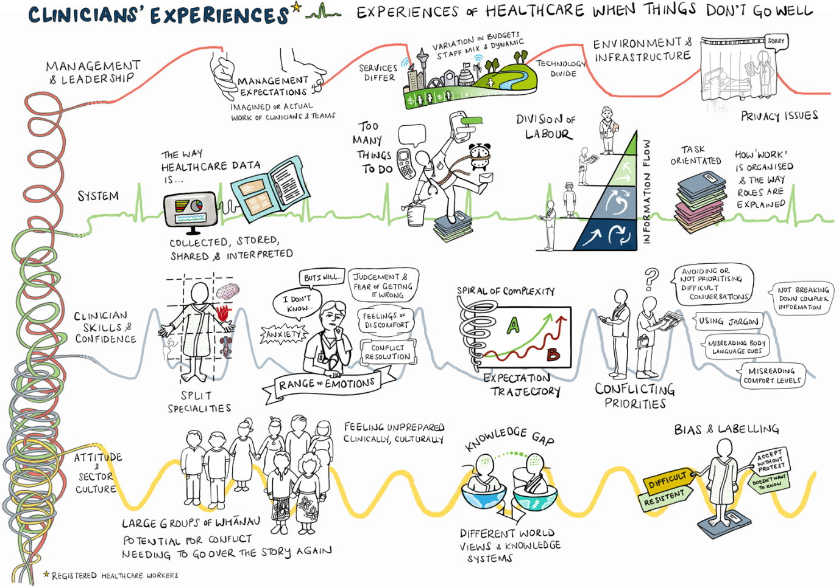
Factors for successful implementation
Implementing a shared goals of care approach will impact on clinical practice. Factors for successful implementation include:
Clinical engagement | Ensure that clinicians are aware of the improvements and what is changing, and that they can share their concerns and be listened to. Use data and stories to overcome any initial scepticism and disengagement. Emphasise that these changes are aimed at improving patient safety and enhancing the patient and whānau experience of care.
Clinical governance and leadership | Leadership and governance to manage this is important. A clinical governance group is needed to ensure that the approach is adequately supported and integrated into the recognition and response system as well as other systems, workflow and processes. Ongoing clinical governance is needed to ensure that what is put in place is functioning successfully.  Having strong and visible clinical leads will help with reaching agreements, resolving issues and raising awareness. In addition, having clinical champions can help staff in their clinical areas with support and mentoring to make the improvements.
Measurement for improvement | Measuring helps teams and clinical governance groups understand how successful the new approach is being implemented and identify areas for further quality improvement. Agreeing what will be measured and when and how it will be used is important to ensure that the improvement happens and is sustained.
Clinical and quality improvement capability | The clinical governance group needs to ensure clinicians have the right capabilities for engaging in shared goals of care discussions, documenting goals of care and using that information should the person deteriorate. Drawing on quality improvement capability within the hospital(s) will ensure the team uses quality improvement methods in the implementation of the shared goals of care approach.
Before implementation, all hospitals should have:
- a project lead, clinical leads (nursing and medicine) and a multi-disciplinary project team that will support the preparation and implementation
- an agreed project charter that includes what will be implemented and how this will be done, timeframes, who are involved, a measurement plan, and strategies for sustainability and engaging stakeholders
- agreement on what improvements are to be made to align with the shared goals of care principles
- a clinical governance group with clinical leaders accountable for ongoing oversight, sustaining and improving the quality of shared goals of care discussions – this group should link into the governance group of the overall recognition and response system
- initial and ongoing education for staff on shared goals of care and communication skills using a structured process, such as the Serious Illness Conversation Guide
- updated and agreed policies.
Tools, guidance, training resources and support for project teams
Specific tools and guidance have been developed to help you prepare for and implement your shared goals of care approach (Table 2).
Table 2: Components with supporting tools and guidance
Component | Supporting tools and guidance
Preparation | - Shared goals of care principles  - Shared goals of care form  - Case for change  - Current approach assessment tool  - Project charter template  - Stakeholder analysis sheet  - Clinical governance recommendations  - Shared goals of care example policy  - Countdown to launch posters
Awareness and promotion | - Factsheets for executives  - Factsheets for clinicians having the discussion  - Factsheet for clinicians supporting the discussion  - Factsheet for responding clinicians  - Factsheet on capabilities  - Patient information leaflet  - Infographic on shared goals of care discussions
Education and training | - Shared goals of care introductory PowerPoint slideshow  - Serious Illness Conversation Guide and online training resources  - Advance care planning training and resources, including the legal framework, overview presentations
Measurement | - Measurement guidance  - Audit tool  - Data collection tool
You can access or download these tools, guidance and training resources from the Commission’s website.

Commission support for project teams
Our support to you includes:
- downloadable tools to assist with preparation and implementation
- regional workshops in May and June 2021
- quality improvement advice and tools for measurement
- regular Zoom meetings to share progress, discuss issues and general network opportunities
- contact with clinical expertise and advice for clinical leads and teams
- national clinical leads to support your grand rounds.
Prepare for implementation
We’ve grouped activities under main preparation areas. You may already have made progress in these areas. Please review the activities to make sure you haven’t missed something.

1. Plan your project
Align the project to your organisation’s aim
Aligning the project to the organisation’s aim, values and strategic plan helps you engage with senior members of the organisation. You can communicate how your project relates to and benefits the organisation.
Establish the executive sponsor(s)
Having an executive sponsor raises the profile of the project and communicates to other staff that the project is a priority for the organisation. Confirm with your executive sponsor(s) what dedicated time the team and other staff can commit to participate. Find out what other resources are available.
Agree project oversight
Work with your executive sponsor to agree project oversight and reporting lines. There may already be a related committee or group that you can fit the project into (such as a patient deterioration or clinical practice committee). As the project progresses you will need to link project oversight to ongoing system clinical governance to ensure sustainability. Consider links with existing groups or committees and agree the oversight relationship.
Agree project reporting
Reporting progress raises the profile of the work you are doing and keeps you focused on what needs to be done and when. It also allows you to raise risks, challenges and issues for assistance. Agree what reporting will be done, who will be responsible, what will be included in the report(s) and who the report(s) will be distributed to.
Establish the project team
Consider what skills, networks and knowledge are needed to complete the project, such as:
- project management  - clinical knowledge and leadership from both ward and responder perspectives  - te ao Māori and Pacific  - consumer advocacy  - advance care planning  - end-of-life care | - leadership  - quality improvement  - data analysis  - education and training  - organisational networking and communication  - information technology.
Ensure that you invite your advance care planning team to be part of the team. Make sure the project team also includes patient and whānau members and representatives from different staff groups who can actively contribute to the project.
Consider how long the project team will be in place and how they can be supported.
Agree what you are trying to accomplish
It’s important to know what you want to accomplish and why. As a team, create a clear statement of your aim. At this stage it is about aligning your current approach with the shared goals of care principles. Start developing a driver diagram as a starting point, then update this and your aim as you understand more about your current approach and what is needed to align with the shared goals of care principles.
This helps with confirming the scope of your project and having a shared purpose. You may need to clarify the terms and definitions that you use so that there is a common language within your project team and organisation.
Agree how you will know that you have been successful
Develop and agree how you will measure successful implementation with your team. Creating agreed balance, process and outcome measures will also help you monitor implementation and track improvements as you progress through testing and implementation. There are some measures we recommend you collect; your organisation may want further measures collected to inform local evaluation and improvement as the project progresses.
Review the measurement guidance and develop a data collection plan.
Know who you need to engage with to accomplish your aim
Engaging with staff and other stakeholders will be crucial to the success of the implementation. Below is a three-step process you can follow with your project team.
- Identify who your stakeholders are:
  - What are the key clinical groups? Do you know how many in each group you have? Do you know how you can best access members of these different groups (that is, are there key meetings where you can present and seek input into your work)?
  - What staff groups outside of the implementation areas will be affected? For example, Māori health experts, radiologists, physiotherapists, consumer engagement and other allied health staff should be aware. Nursing and medical educators, switchboard staff, orderlies and stock control staff may have a role in supporting implementation. Think about operational and senior management groups that you need to engage with.
  - Consider how you can engage patients and their whānau. Talk with chaplains and other spiritual advisors about how they can be involved.
- Assess how much influence these groups have on the success of the project and how much interest they have. Use the stakeholder assessment template.
- Once you have assessed your stakeholders, identify strategies to keep all stakeholders with a high impact on your project engaged. If you have stakeholders that have a high impact on the project but low interest in it, identify how you can increase their interest. You could use your champions to directly engage with them.

Agree how you will engage with staff and other groups
Now that you’ve agreed who you need to engage with, work out how you will do this. Every member of the project team will have a part to play in this.
Look at where there are existing staff meetings, networks or communication pathways. Use a mixture of formal meeting presentations and informal discussions.
Consider how the messages should be framed to influence and engage staff. Think about who will be the right people to do the engagement. There may be groups where an enthusiastic peer or champion will need to speak with them. Direct peer-to-peer engagement is often required to effectively communicate your key messages. Ask your communications team to help you reach the wider staff group through the intranet or existing newsletters.
Engagement activities will be needed throughout preparation and implementation. The messages you give may change to reflect the progress you have made. Consider what data (for example, audit data, case review findings, outcome measures) should be reported to different groups and in different forums (for example, at medical grand rounds, morbidity and mortality reviews or ward meetings).
Use the infographic and factsheets to support your engagement work.
Document agreements in your project charter
Bring all the agreements you have made into one document – the project charter. This will help guide the work that you do. Use the project charter template if you don’t have one to use in your organisation.

2. Prepare what you will do and how you will do it
Know your starting point
Your organisation may have components of shared goals of care already established. Use a range of activities to understand what is currently happening and how patients, whānau and staff experience it.
Find out:
- what the current approach for shared goals of care is – if there isn’t one, find out what information wards and rapid response teams currently use to determine what to do when a patient deteriorates
- how staff, patients and whānau experience the current approach – you could use observation, interviews, focus groups and hui
- how staff received training and education to support the current approach
- what information is currently collected, who uses it, where is it reported and what is it used for – this could include data from audits, national minimum data set reports, adverse event reporting, complaints and compliments.
Document what you currently have and what processes are working well or need improvement. Use the current approach assessment tool to guide you.
Review the shared goals of care principles
Once you know your starting point, work through the current approach assessment tool. This helps you to align with the shared goals of care principles and decide your shared goals approach and what changes you need to make.
Find multiple opportunities to discuss the proposed shared goals of care approach with different clinical groups so that they understand the implications for their work.
Remember that the focus is not about changing to a new form. This is about creating the environment and supporting patients, whānau and clinicians to have shared goals of care discussions.
Assess the challenges and opportunities
Changing the approach will have both challenges and opportunities. Consider what these could be with the project team. Think about how staff, patients and whānau currently interact with the approach and the team cultures and processes that underpin their actions. Identify what you will do to maximise the opportunities and address the challenges.
Use the list below to prompt exploring the challenges, opportunities and actions in your organisation:
- patient and whānau  - staff (including volunteers)  - environment  - processes  - tasks | - time  - team  - communication and documentation  - education and training  - policies.
Agree what you will be testing and how you will do this
Get agreement on what you will be testing, where and when. Set realistic timelines that include developing what you will be testing. Update your aim statement, driver diagram and project timelines.
Build in time to prepare and to engage with clinicians, patients and whānau.
Consider how and when training and education on shared goals of care and the Serious Illness Conversation Guide will be provided. Please note that if you do not already have Serious Illness Conversation Guide trainers delivering workshops in your organisation, your project timeframe will need to take into consideration the time to get trainers trained. The train-the-trainer training is delivered by the advance care planning and clinical communication programmes at the Commission (SICGadmin@hqsc.govt.nz).
We recommend using a quality improvement approach using plan-do-study-act (PDSA) cycles to test the interventions on a small scale before rolling it out hospital-wide. You could do this by starting with one ward to test the interventions. This is described in Appendix A.
It is important to agree how you will manage the clinical risks of potentially having more than one way of documenting shared goals of care in the hospital during this testing.
Assign specific activities to team members to lead and contribute to. You may need to establish smaller working groups to tackle specific issues highlighted by this work.
Build in sustainability
Project teams are generally short term, with a focus on initial implementation. Consider at this stage how the changes you introduce will be sustained after the initial project has been completed. Ongoing clinical leadership and governance structures are critical to this.
We suggest using the NHS Sustainability Model to guide your preparing. This will help identify areas where you need to focus for successful and sustained system improvement.
Identify a test ward(s)
As you engage with staff, check who would be willing to be an initial ward(s) for testing your shared goals of care approach. Those who are willing are more likely to be actively looking for solutions and overcome obstacles during the initial improvement cycles.
Decide:
- which patients will form part of the test
- what workflows this change will impact within the test ward
- which staff will be involved and what their roles will be
- what training and education staff in the area will need about patient deterioration, shared goals of care, communication, the Serious Illness Conversation Guide, and documentation to fulfil their test site roles
- how new staff coming into the test site area during the test will be oriented and trained (especially new or agency nurses and junior doctors)
- what documentation processes you will need to include.
Agree where clinical governance for your shared goals of care approach will reside
Review the clinical governance recommendations. As part of establishing the shared goals of care approach, you need to get agreement on which clinical governance group will have ongoing responsibility for shared goals of care and its continuous improvement beyond the project. This may be within the patient deterioration clinical governance group, as part of the advance care planning governance, organisational learning and development, or within a broader end-of-life care governance. Planning the ongoing clinical governance arrangements early will improve engagement and embed the approach into business as usual.
Regardless of where you decide to put this ongoing clinical governance, make sure that the terms of reference reflect the clinical governance recommendations. Consider how clinical governance aligns with the operational management of the system.
Update your project charter
Update your project charter to bring all the agreements you have made about what you will be testing and the plan for doing the testing. This will help guide the work that you do.

3. Do small-scale tests of the shared goals of care approach
Prepare your initial ward(s) for testing
Meet with staff on your initial ward(s) to agree when they will start using the shared goals of care approach and explain how the improvement cycles will work. Let them know:
- how the approach will work, particularly if this is a significant change from the current approach
- the support that they will receive and who will provide this
- when their ward-based training sessions on the approach will take place
- when their Serious Illness Conversation Guide training sessions will take place
- how they can provide feedback on the approach they are testing
- that they are shaping how the shared goals of care approach will work in the hospital(s).
Manage your testing
Make small steps of change with your initial ward(s) until they and your team feel you are ready to implement across the ward.
Meet regularly with staff to gather their feedback on the approach. Use the measures and data collection processes you identified earlier to monitor your progress. Meet regularly as a project team to go through this data and record where changes to the approach have been agreed.
Agree any changes to the shared goals of care approach
Report back to your project sponsor and oversight group on the results of the testing. Share the changes made to the approach and recommend what the revised approach will be. Recommend where the next wards will be for implementing the approach.
Communicate your project to the organisation
Share what you are doing with the wider organisation and create opportunities for staff to provide feedback. This will raise awareness, generate interest in the project and make it visible at all levels of the organisation. Consider having items in internal communications and reports to the Board and senior level groups.
Engage with staff at every opportunity
You have identified how you want to engage with staff. Use these strategies to share key messages and take staff on the journey with you. As well as planned activities, be open to other opportunities that may present themselves. Listen to concerns, suggestions and what works well.
Celebrate success
On successful completion of the testing:
- gather patient, whānau and staff stories from the testing
- share these with your stakeholders and sponsors
- celebrate with the test ward(s) and your team
- capture and share lessons learnt.

4. Prepare for spread and implementation
Agree the spread, implementation and launch plan
Working with your sponsors, stakeholders and team, agree how you will spread the interventions beyond your test ward(s). You can use your planning from the testing as a template to help you with this. Use your learning from the testing to shape what interventions will be spread and implemented across the hospital. Update your aim statement, driver diagram and project timelines. Build in time to prepare and to engage with clinicians, patients and whānau.
Consider having champions who can provide help to staff in their clinical areas during preparation and implementation, support audit data collection and sustain the changes over time.
Agree how you will phase implementation across your hospital(s). Plan how you will communicate with staff and how education and training will be scheduled. Decide how you will launch your shared goals of care approach. Update your project charter with all that you have agreed.
Ensure adequate supplies of patient information resources
Review what patient information resources will be needed as part of the roll-out. Consider whether these will be provided in different languages and formats and how patients and whānau will be able to access them. Create a process for ordering and replenishing these resources.
Update your local policies
Do a stocktake of policies that relate to shared goals of care, including resuscitation and advance care planning. Use the sample policy as a guide.
There is likely to be a range of other policies. Talk with stakeholders about this and make a list of how they are impacted. Review and update the policies to reflect your changes.
Do a stocktake of your equivalent form
Review the current stock level of your current forms ahead of implementation. Make sure there will be enough stock of your current form for use while you roll out the new approach. Find out when you need to have the new version of the form to your printers so stocks will be ready for launch.
Agree the date and time when these new stocks will be made available to areas and old stock removed. This same process should be used for implementing any updates agreed nationally.
Prepare your wards for spread and implementation
Meet with staff on your wards to agree when they will start using the shared goals of care approach. Let them know:
- how the approach will work, particularly if this is a significant change from the current approach
- the support that they will receive and who will provide this
- when their ward-based training sessions on the approach will take place
- when their Serious Illness Conversation Guide training sessions will take place
- how they can provide feedback on the approach in the initial stages.
Engage with staff at every opportunity
Continue to engage with staff about the project. Keep those who will be impacted up to date with progress and what they need to be doing and by when.
Communicate your project to the organisation
Continue to share what you are doing with the wider organisation. Make sure people are aware of your launch date and roll-out schedule. You may want to have a celebration to mark the occasion.
Check staff are prepared
Meet with staff to make sure they are ready to begin, and answer questions. Check that they have attended training. Make sure project team members are visible and can answer queries.
Put new forms and resources into your agreed area(s)
Make sure older forms and information resources are removed.

Implement
We’ve identified some activities that you can incorporate into your implementation plan.
Monitor progress and make small steps of change
Make sure project team members are visible and available to troubleshoot, answer questions and provide support during the initial days and weeks of implementation. It can be helpful to have members of the executive team visit the area to support the implementation.
Check in with areas regularly to see how they are going, answer queries, resolve issues and collect information. Work with area champions to provide help to staff in their area.
If staff have identified related change ideas to test through PDSA cycles, work with staff to make small steps of change until they and your team feel you are ready to spread the change idea further.
Measure for improvement
Use the measures and data collection processes you identified during the preparation period to monitor your progress towards achieving your aim(s). Use the measurement guidance and the tools you developed during testing.
Report on progress to your executive sponsor and project oversight group
Continue to give regular progress updates to your executive sponsor and project oversight group.
Train new staff and provide ongoing training
Train staff in line with your decisions during the preparation stage. Doing audits provides an opportunity for one-to-one training as well as deciding what additional training needs to be provided.
Celebrate achievements by the team and those implementing
Take the time to celebrate achievements and the efforts of team members and those in the implementing areas. Positive feedback and reinforcement combined with public recognition will help keep everyone motivated and focused.
Handover to those responsible for the ongoing sustainability of the system
Meet with those who will be responsible for ongoing training, measurement and monitoring of the system. Ensure they are aware of their links with the clinical governance group.

Appendix A: Quality improvement approach
The Model for Improvement (Figure 2) was developed by the Associates for Process Improvement (www.apiweb.org) and has been used in a number of quality improvements for health care organisations.
The Model for Improvement is a framework for structured improvement activity to help you achieve your goals and support the spread for wider adoption. It is based on three fundamental questions used alongside small-scale testing, often referred to as PDSA cycles. As part of your preparation period, you will address the three questions. During your implementation you can use PDSA cycles to test out related change ideas.
Figure 2: The Model for Improvement
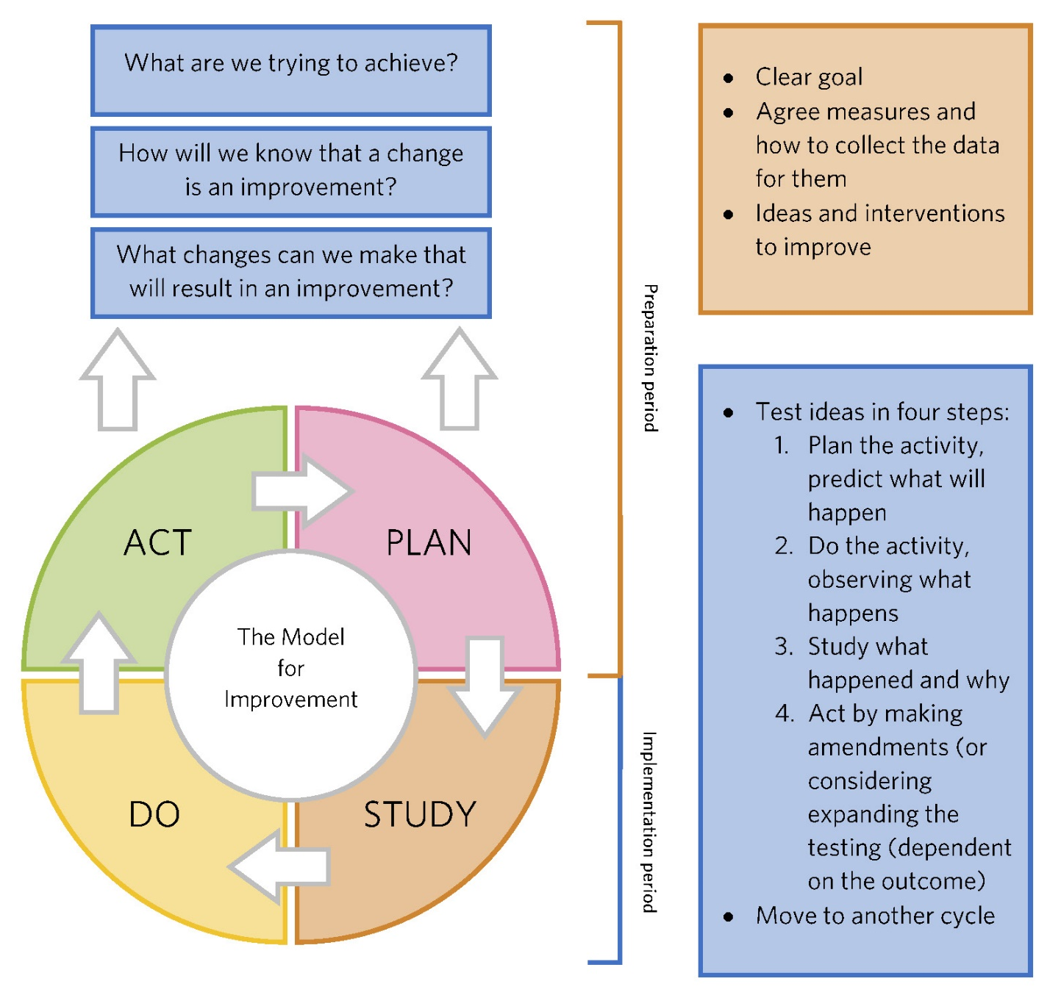

Here are some tips for doing the PDSA cycles:
- Expect the test not to work the first time.
- Starting with one patient and one team means that there is minimum delay to starting, the test can be observed easily and the impact is minimal if it doesn’t work.
- Spread slowly. Once it works for one, test with three and then five. This will help you resolve issues so that you have confidence.
- Work with the willing. Find a team that want the change to work – they will have the patience.
- Use simulation if you are concerned about the impact – this could be as a desk review and/or a walk-through with colleagues.
- Assess whether testing will have an impact on people or processes beyond the area. Include them in the planning and studying stages of the cycle. We’ve recommended assessing the challenges and opportunities during the preparation period.
There are other improvement methods like Lean and Six Sigma. Use these if your organisation has a stated preference for one over another.
Nearly every DHB has quality improvement advisors that you can contact for support and guidance.
Appendix B: The Serious Illness Conversation Guide
Best practice in discussing goals of care includes:
- preparing for the discussion
- relating to the patient
- sharing prognostic information
- acknowledging emotions and concerns
- eliciting decision-making preferences
- understanding fears and goals
- exploring views on trade-offs and impaired function
- wishes for family involvement
- encouraging questions.,
To support best practice, it is recommended that clinicians use the Serious Illness Conversation Guide framework to support shared goals of care discussions.
When clinicians face stressful situations, like a shared goals of care discussion, it helps to have language to turn to, to make sure the clinician covers the key questions and addresses the important issues in an efficient and patient-centred way.
The Serious Illness Conversation Guide was developed by Ariadne Labs and adapted for Aotearoa New Zealand. It is a framework for best communication practices that clinicians are finding useful to structure and support shared decision-making in practice.
The Serious Illness Conversation Guide is a set of structured questions to help clinicians have discussions with seriously ill people and their whānau about what is most important to them if time were limited and/or their condition was to decline.
It is made up of patient-tested language and explores:
- the person’s understanding of their illness
- their preference for information
- the sharing of a prognosis (this should include risk of deterioration while in hospital)
- the person’s:
- goals
- fears and worries
- the abilities they find most important
- the ‘trade offs’ they are willing to make for the possibility of more time
- how much their whānau know.
It concludes with shared planning and agreeing goals of care should the person deteriorate that are consistent with the person’s values and goals.
For more information about the Serious Illness Conversation Guide, see https://www.hqsc.govt.nz/our-programmes/advance-care-planning/information-for-clinicians/tools/serious-illness-conversations/.

Appendix C: Shared goals of care discussion infographic
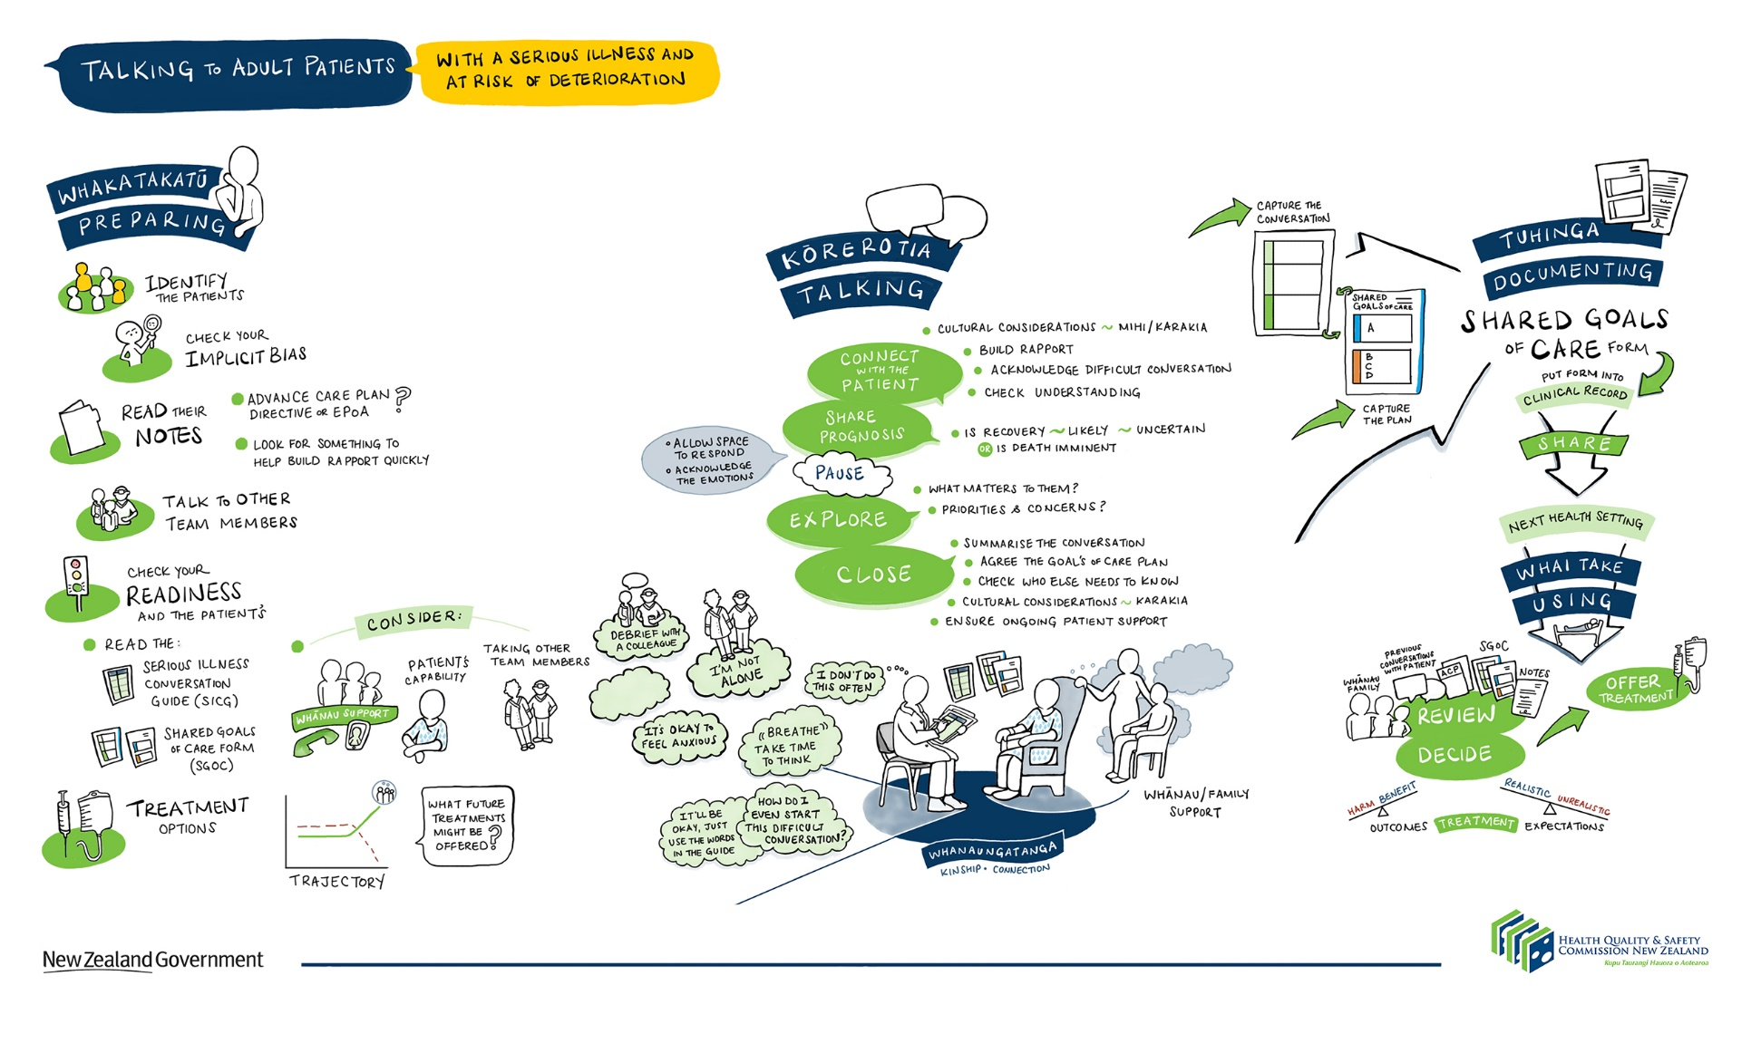
References

Psirides A, Hill J, Jones D. 2016. Rapid response team activation in New Zealand hospitals: A multicentre prospective observational study. Anaesthesia & Intensive Care 44(3) (in press).
Stockdale C, Trivedi B, Jerome E, et al. 2013. Implementation of a combined cardiopulmonary resuscitation and treatment escalation plan document in a district general hospital. BMJ Quality Improvement Reports 2.
Wright AA, Mack JW, Kritek PA, et al. 2010. Influence of patients’ preferences and treatment site on cancer patients’ end-of-life care. Cancer 116: 4656–63.
Detering KM, Hancock AD, Reade MC, et al. 2010. The impact of advance care planning on end of life care in elderly patients: Randomised controlled trial. BMJ 340: c1345.
Temel JS, Greeer JA, Muzikansky A, et al. 2010, Early palliative care for patients with metastatic non-small-cell lung cancer. New England Journal of Medicine 363: 733–42.
Clayton JM, Hancock KM, Butow PN, et al. 2007. Clinical practice guidelines for communicating prognosis and end-of-life issues with adults in advanced stages of a life-limiting illness, and their caregivers. Medical Journal of Australia 186(S12): S77–105.
Bernacki RE, Block SD. 2014. Communication about serious illness care goals – a review and synthesis of best practices. JAMA Internal Medicine 174(12): 1994–2003.
NHS Institute for Innovation and Improvement. 2010. Sustainability model and guide. URL: http://webarchive.nationalarchives.gov.uk/20160805122021/http://www.nhsiq.nhs.uk/media/2757778/nhs_sustainability_model_-_february_2010_1_.pdf (accessed 29 June 2017).
Patient Safety First. 2008. The quick guide to implementing improvement. URL: http://webarchive.nationalarchives.gov.uk/20091118133206/http://patientsafetyfirst.nhs.uk/ashx/Asset.ashx?path=/How-to-guides-2008-09-19/Quick%20Guide%201.1_17sept08.pdf (accessed 29 June 2017).
Bernacki RE, Block SD. 2014. Communication about serious illness care goals – a review and synthesis of best practices. JAMA Intern Med Doi:10:1001.
Wright AA, Mack JW, Kritek PA, et al. 2010. Influence of patients’ preferences and treatment site on cancer patients’ end-of-life care. Cancer 116: 4656-63; Detering KM, Hancock AD, Reade MC, et al. 2010. The impact of advance care planning on end of life care in elderly patients: randomised controlled trial. BMJ 340:c1345; Temel JS, Greeer JA, Muzikansky A, et al. 2010, Early palliative care for patients with metastatic non-small-cell lung cancer. N Eng J Med 363: 733-42.
Ariadne Labs is an American non-profit organisation lead by Atul Gawande (author of Being Mortal). URL: https://www.ariadnelabs.org/areas-of-work/serious-illness-care/ (accessed 24 March 2020).

